Indian School Al Wadi Al Kabir
Computer Applications (Code 165)
Sample Examination Question paper

Class: X Date: 07-03-2024
Maximum Marks: 50 Time Allowed: 2 hours

General Instructions:
1. This Question Paper has 5 Sections A-E.
2. All Questions are compulsory. However, internal choices have been provided in some of the questions.
3. Section A has 12 questions carrying 01 mark each.
4. Section B has 7 Short Answer (SA-I) type questions carrying 02 marks each.
5. Section C has 4 Short Answer (SA-II) type questions carrying 03 marks each.
6. Section D has 1 Long Answer (LA) type question carrying 04 marks.
7. Section E has 2 Source based /Case-based /Passage based Questions carrying 04 marks each.
Section – A
(All Questions are Compulsory) [1 mark]
Question 1.
Which of these is an example of an e-governance website?
(A) amazon.com
(B) cbse.nic.in
(C) india.gov.in
(D) brainly.nic.in
Question 2.
Which one of the following would breach the integrity of a system?
(A) Looking the room to prevent theft
(B) Full access rights for all users
(C) Fitting the system with an anti-theft device
(D) Protecting the device against willful or accidental damage
Question 3.
Web address of national portal of India is:
(A) India.gov.in
(B) GOI.gov.in
(C) ncert.nic.in
(D) None of the above
Questions 4.
Software programs that allow you to legally copy files and give them away at no cost are called which of the following?
(A) Probe ware
(B) Timeshare
(C) Shareware
(D) Public domain
Questions 5.
The term FTP stands for?
(A) File transfer program
(B) File transmission protocol
(C) File transfer protocol
(D) File transfer protection
Question 6.
When the mail server sends mail to other mail servers it becomes _____?
(A) SMTP client
(B) SMTP server
(C) Peer
(D) Master
Question 7.
Who invented HTML?
(A) Dave Raggett
(B) Tim Berners-Lee
(C) Denis Ritchie
(D) All of the above
Questions 8.
Can we hide inline content using the comment?
(A) Yes
(B) No
9. Which element/tag defines a paragraph?
(A) <p>
(B) <pre>
(C) <panel>
(D) None of the above
Question 10.
Which tag is the root element of an HTML page?
(A) <html>
(B) <title>
(C) <head>
(D) <body>
Questions No-11 & 12 are Assertion and Reason types. Each question consists of two statements, namely, Assertion (A) and Reason (R). Select the most suitable option considering the Assertion & Reason.
DIRECTIONS: In each of the questions given below, there are two statements marked as Assertion (A) and Reason (R). Mark your answer as per the codes provided below:
(A) Both A and R are true and R is the correct explanation of A.
(B) Both A and R are true but R is not the correct explanation of A.
(C) A is true but R is false.
(D) A is false but R is true.
(E) Both A and R are false.
Question 11.
Assertion (A): <hr> tag is an empty tag.
Reason (R): <hr> tag is horizontal ruler tag.
Question 12.
Assertion (A): <dl> tag is use to create a Definition list.
Reason (R): <Li> is a attribute of <dl> command.
Section – B
[2 marks]
Question 13.
What is E-paper news?
Question 14.
What are e-mails?
OR
How do I open email on my phone?
Questions 15.
How do I make a URL link in HTML?
Question 16.
What is secure data transmission?
OR
Kuhu has just learnt how to do online banking. Name any two precautions that she should take to prevent online fraud.
Questions 17.
Is HTML and CSS a programming language?
Questions 18.
Identify the errors and write the correct HTML code
(i) <table bgcolour=”Red”>
(ii) <pic style=” abc.jpeg”>
OR
What for anchor tag is used?
Questions 19.
write the code for creating a A basic HTML table in CSS:
Company | Contact
Alfreds Futterkiste | Maria Anders
Centro comercial Moctezuma | Francisco Chang
Section – C
[3 marks]
Question 20.
Who uses Digital Signatures? Who provides digital signature?
Question 21.
In how many ways can we access the internet?
Question 22.
Is head tag necessary in HTML? What is title tag?
OR
What is checkbox example? Which tag creates a checkbox in HTML?
Question 23.
Is crypto a real money? What are the four types of crypto currency?
Section – D [4 Marks]
Question 24.
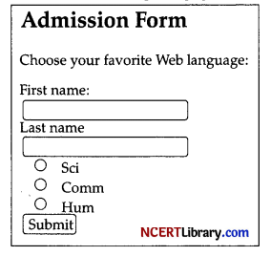

Observe the following web page.
Write the HTML code to design the above shown web page considering the specifications as given below:
Specification 1: Heading level 2 for words- “Admission Form”.
Specification 2 : Add to Input box to write First Name and Last Name.
Specification 3 : Add radio button for selecting Stream.
Specification 4 : Add submit button to submit form.
Specification 5 : Write 2nd line of web page in paragraph tag.
OR
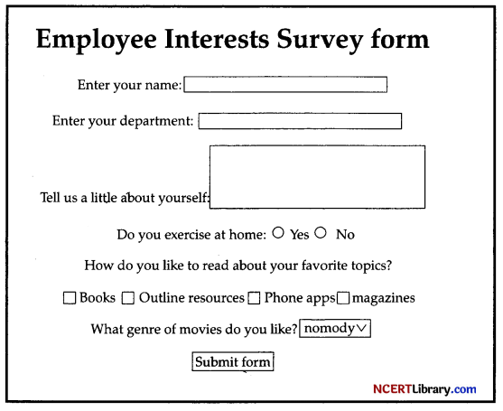
Write the HTML code to design the above shown web page considering the specifications as given below:
Specification 1: Title should be “Employee Interests Survey”.
Specification 2 : Add highest Heading level for words- “Employee Interests Survey form”.
Specification 3 : Add to Input box to write Name and Department.
Specification 4 : Add checkbox to select topics.
Specification 5 : Add submit button to submit form.

Section – E
[4 Marks]
Question 25.
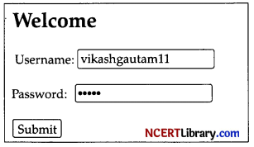
Write HTML code to generate the following code.
<!DOCTYPE html>
<html>
<head>
<title>Page Title</title>
</head>
<body>
<h2>Welcome</h2>
<_____> <!-STATEMENT-1>
<p>
<label>Username: <_____ type=”text” /></label> <!-STATEMENT-2>
<p>
<label>Password: cinput type=”_____” /></label> <!-STATEMENT-3>
</p>
<p>
<_____ type=”submit”>submit</button> <!-STATEMENT-4>
</p>
<_____> <!-STATEMENT-5>
</body>
</html>
(A) Write the appropriate answer for the blank given in Statement-1
(B) Write suitable tag for the blanks given in Statement-2.
(C) Write the appropriate answer for the blank given in Statement-3
(D) Write the appropriate answer for the blank given in Statement-4
(E) Write the appropriate answer for the blank given in Statement-5
Question 26.
Netiquette
Netiquette is a combination of the words network and etiquette and is defined as a set of rules for acceptable online behaviour. Similarly, online ethics focuses on the acceptable use of online resources in an online social environment. Netiquette exists to help people to communicate more effectively whilst online, and to avoid unnecessary misunderstandings and potential conflicts. Without a sound understanding of netiquette you run the risk of displaying abusive or cyber bullying type behaviour without even being aware of it. Netiquette is a new word and concept for some of us, but a basic understanding of netiquette is important for everybody that uses the internet.
(i) Netiquette is short for:
(ii) ……….. is a set of rules for acceptable online behaviour.
(iii) ……… is a code of polite behaviour in society.
(iv) Avoid posting ……….. comments online.
(v) ………… other when you are new.

